Have you ever wondered if we are offering the most competitive wages to keep our employees happy? Does our salary match with other local and statewide hospitals? Tuesday, July 1, 2025, Savio HR Solutions will be opening its annual Mississippi Hospital Association Salary Survey to statewide Mississippi hospitals.
The survey is open to all hospitals within the state of Mississippi. You do not have to be a member of the Mississippi Hospital Association to participate. The cost for the survey is $300 per facility per year.
Once you enroll in the salary survey you receive a link to the survey database. You will submit your information through the corresponding website. If you need assistance entering your information, let us help you. Do not let the lack of time or technical skills keep you from this very valuable information.
Friday, August 29, 2025, we will close the survey and allow all the collected data to be untouched for 90 days. Once the 90 days have been completed, all participants will receive the composite information and will have access to it anytime you wish.
Here are some examples of the results you would see in your reports (information from 2024):

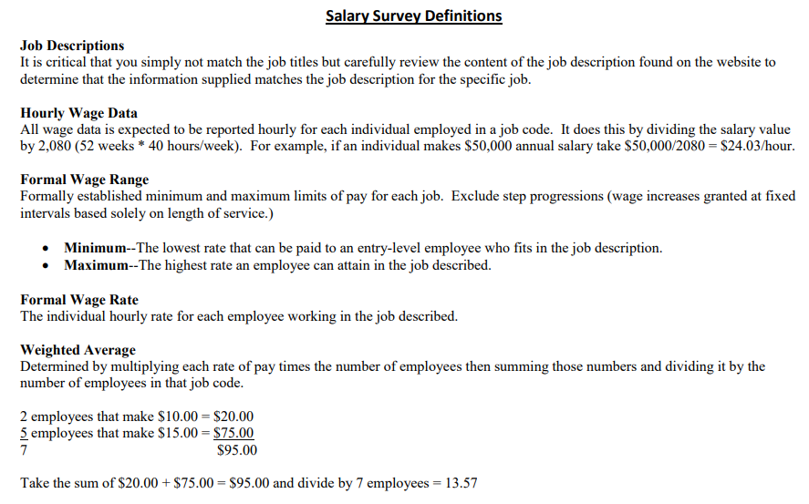
If you have any questions, please do not hesitate to contact Tammy Brown with Savio HR Solutions directly.

Tammy Brown
Survey Administrator
Office Number: 601-368-3309
Email: tbrown@saviosmart.com

